- Set up a Google Alert for your favorite IPL team or a trending Bollywood movie and take a screenshot of the alert confirmation page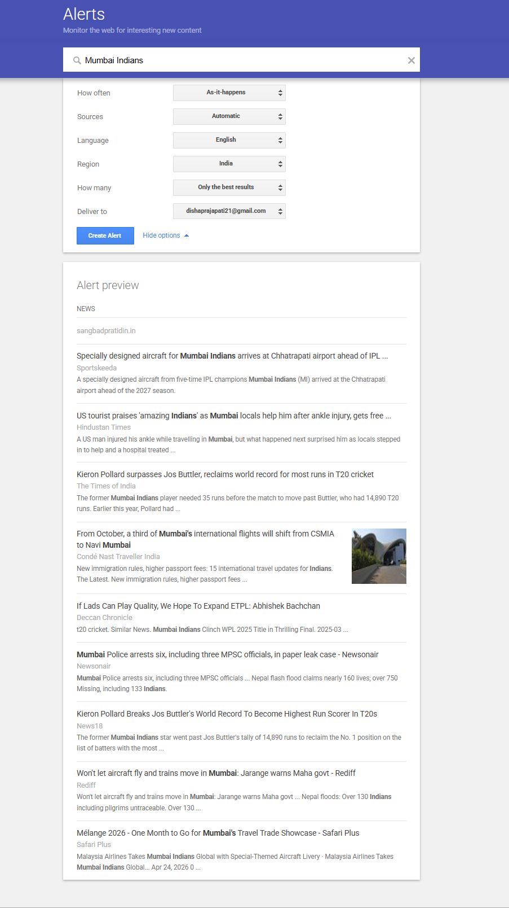
- Find 3 recent online articles or blog posts that mention a popular Indian food delivery app (like Zomato or Swiggy) but do not link to its official website, and list their URLs.
# | Article | App mentioned | Date | URL
1 | Zomato, Swiggy and now Flipkart: India's food delivery war just got a powerful new player | Zomato & Swiggy | Aug 4, 2026 | Business Today article
2 | Bengaluru restaurants warn of Swiggy, Zomato boycott after Aug 15 over commissions | Swiggy & Zomato | Jul 29, 2026 | India Today article
3 | Consumer commission penalises Zomato, hotel for non-veg burger delivery | Zomato | Jul 14, 2026 | New Indian Express article
- Use the free version of the Mention tool (https://mention.com/en/) or BrandMentions (https://brandmentions.com/) to track brand mentions for a well-known smartphone brand in India (such as OnePlus or Realme) and submit a screenshot showing at least one mention found.
Didn’t work
- Write a short email template you could send to a website owner, requesting them to convert an unlinked mention of your favorite music app (like Spotify or Gaana) into a clickable link to the app’s official site.
Dear Website Owner,
I noticed that your article mentions Spotify, but the mention is not linked. Could you please make “Spotify” a clickable link to the official Spotify website?
This would make it easier for your readers to visit Spotify and explore the app.
Thank you for your time and consideration.
Best regards,
Disha
- Use ChatGPT to generate a list of 3 creative digital PR strategies for increasing brand mentions for a new fashion e-commerce startup targeting Gen Z in India.<br><br><em><strong>Hint:</strong> Ask ChatGPT to focus on social media collaborations, influencer outreach, and viral challenges.</em>

3 Creative Digital PR Strategies
- Influencer Collaborations – Partner with popular Indian Gen Z fashion influencers to create Instagram Reels, YouTube Shorts, and outfit videos featuring the brand.
- Viral Fashion Challenge – Start a challenge like #StyleYourWay where users create and share their best outfits using the brand’s products. Give prizes to the most creative entries.
- Social Media Collaborations – Collaborate with college communities, fashion pages, and meme pages to create relatable fashion content that encourages tagging, sharing, and brand mentions.

